

American International University-Bangladesh (AIUB)  
Department of Computer Science  
Faculty of Science &Technology (FST)  
Summer 21 22

Section: D  
Software Quality Assurance and Testing

PROJECT TITLE

A Report submitted

By

|  |  |  |
| --- | --- | --- |
| SN | Student Name | Student ID |
| 1 | REZA, S. M. ASHIL | 19-40455-1 |
| 2 | SORMILA HOSSAIN | 19-40412-1 |
| 3 | ABDULLAH AL SAMAD | 18-38565-2 |
| 4 | MD. SADATUR RAHMAN | 16-32606-2 |
| 5 | MUHAMMAD RIDWAN AHAD | 18-37919-2 |

Under the supervision of

MD. AL-AMIN

Lecturer, CS department, AIUB

Software Test Plan

for

<AIUB Student portal system>

Version 1.0 approved

Prepared by <s. m. ashil reza, sormila Hossain, Abdullah al samad, md. Sadatur Rahman, Muhammad ridwan ahad>

<American International University-Bangladesh>

<22 august, 2022>

**Checked By Industry Personnel**

Name:

Designation:

Company:

Sign:

Date:

Table of Contents

Revision History 3

1. TEST PLAN IDENTIFIER: RS-MTP01.3 3

2. REFERENCES 3

3. INTRODUCTION 3

Background to the Problem 3

Solution to the Problem 4

4. REQUEIREMNT SPECIFICATION 4

4.1 System Features 4

4.2 System Quality Attributes 4

4.3 System Interface 5

4.4 Project Requirements 5

5. FEATURES NOT TO BE TESTED 5

6. TESTING APPROACH 5

6.1 Testing Levels 5

6.2 Test Tools 6

6.3 Meetings 6

7. TEST CASES/TEST ITEMS 6

8. ITEM PASS/FAIL CRITERIA 7

9. TEST DELIVERABLES 7

10. STAFFING AND TRAINING NEEDS 8

11. RESPONSIBILITIES 8

12. TESTING SCHEDULE 8

13. PLANNING RISKS AND CONTINGENCIES 9

14. APROVALS 9

# Revision History

|  |  |  |  |
| --- | --- | --- | --- |
| Revision | Date | Updated by | Update Comments |
| 0.1 | 2022.08.20 | Reza, S. M Ashil | First Draft |
| 0.2 | 2022.08.20 | Sormila hossain | second Draft |
| 0.3 | 2022.08.21 | Md. Sadatur rahman | third Draft |
| 0.4 | 2022.08.21 | Abdullah al samad | Forth Draft |
| 0.5 | 2022.08.21 | Muhammad ridwan ahad | Fifth Draft |

# TEST PLAN IDENTIFIER:RS-MTP01.3

# REFERENCES

* [Index (aiub.edu)](https://portal.aiub.edu/)
* [Test Plan - SOFTWARE TESTING Fundamentals](https://softwaretestingfundamentals.com/test-plan/)

# INTRODUCTION

## Background to the Problem

* In AIUB there is no student portal in their website. So that student can take their courses manually in the campus. Also, the student watched the notice board for see the upcoming notices. All the result of the courses are published in the notice board of the campus. So, for memorizing they need to take pictures or take note of the results. Students need to buy or print course content the varsity doesn’t have any online platform where store the course content. To drop / Retake the course Student have to go from teacher to teacher. So that, at that moment students are suffering from my side to complete their requirements and study because there is no Student portal in the varsity’s website

## Solution to the Problem

* A detailed document that catalogs and enumerates the test strategy, resources, schedule, estimations, and deadlines are referred to as a test plan. These criteria are required for completing a particular project within a given period. This is a test plan developed on AIUB Student portal. This plan will address those items and elements that are related to develop a student portal to make easier student’s daily life o study. In our system student can easily find ta details of current semester courses, notes and results. Student can also take courses for their upcoming semester by using this system. Grade by curriculum and also Grade by semester will take place in our project. So that Student can observe their results and improvements many other features will be add in the future to make AIUB more digital and smarter.

# REQUEIREMNT SPECIFICATION

## System Features

**1. System Login:**

1.1 The software shall allow the entry of only authorized users through a valid login Id and password.

1.2 If the username and/or password has been inserted wrong for more than three times, the random verification code will be generated by the system to retry the login.

1.3 The user should be able to retrieve his/her password by email.

Priority Level: High

Precondition: The user must have a valid user Id and password.

**2. Guest:**

2.1 Go through the website

Priority Level: Medium

## System Quality Attributes



**Usability:** The system is simple to operate. This technique may be used by anyone with a little instruction. Accessibility: The system is open to everybody, and the data it collects is transparent.

**Efficiency:** Each and every functional need must be fulfilled

**Accountability:** proper authority will be notified in case of emergency. This ensures quality testing of the project. Without accountability testing may not be effective.

**Adaptability:** This system and test plan are adaptable; they can be utilized with little to no modification in the future.

**Affordability:** When compared to other systems, this one is reasonably priced. Because every toll plaza is equipped with a camera, implementing those features will be inexpensive. As a result, there is no charge in the hardware department. All that is required is the development of software for the system.

**Maintainability:** If any issue locates or detect in the system then it will be possible to fix it

**Correctness:** Mentioned all features will be completed according to the preferences

of the patients

## System Interface

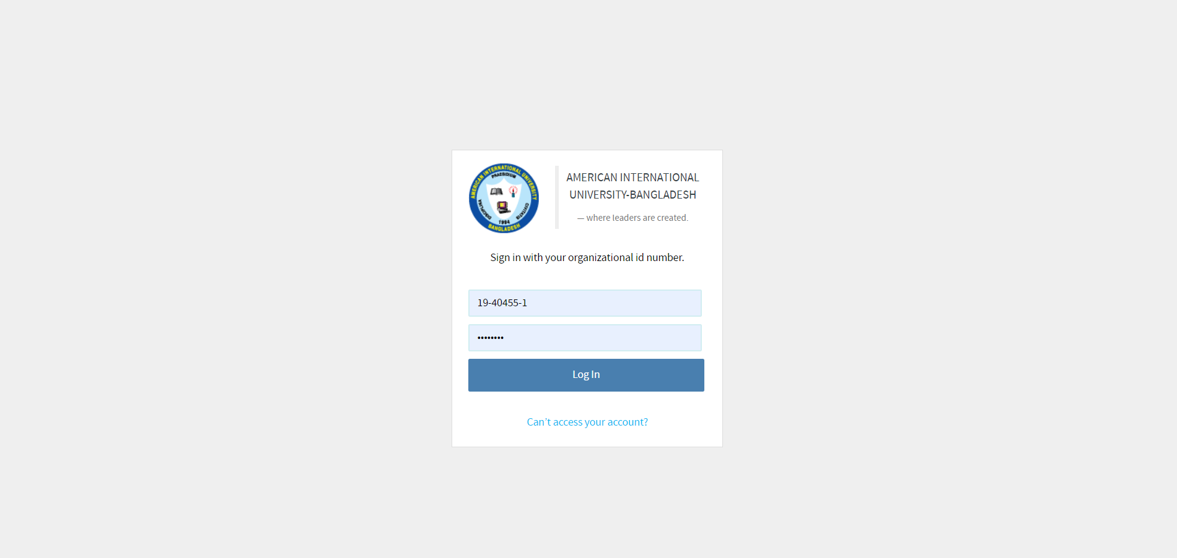

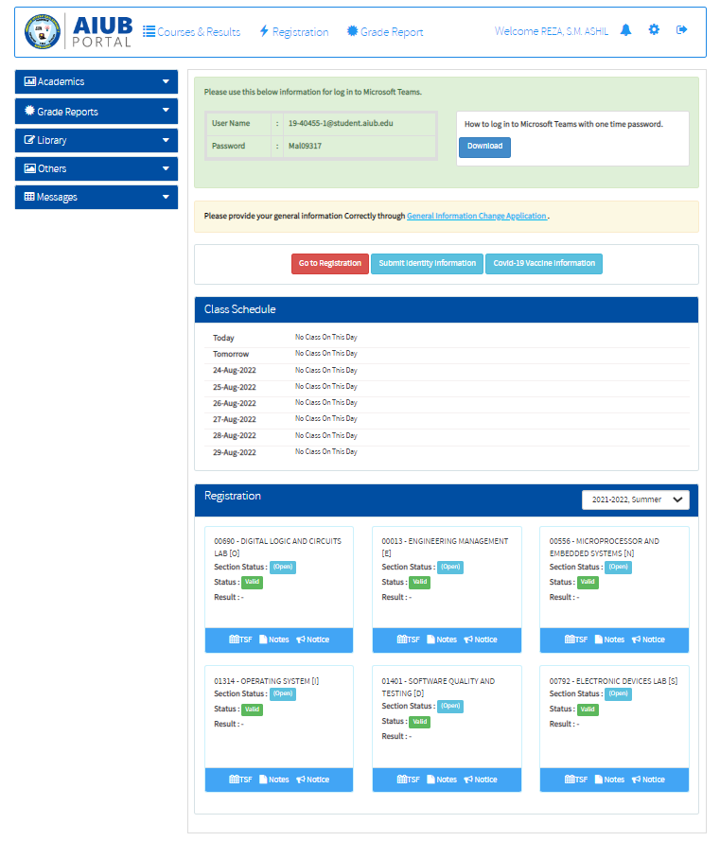

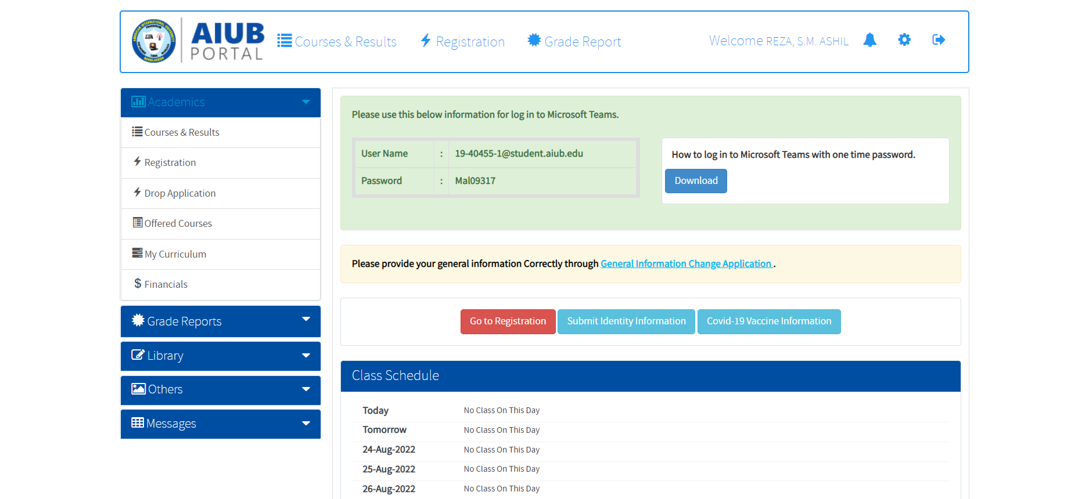

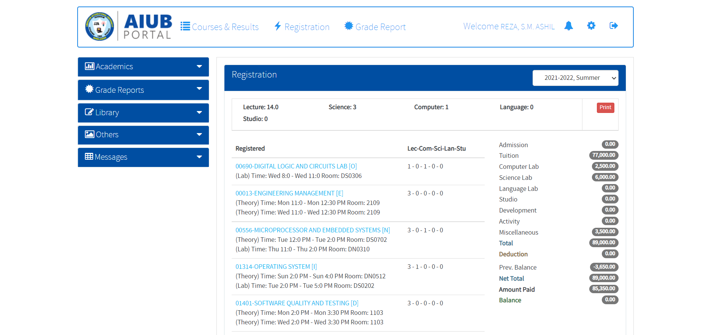

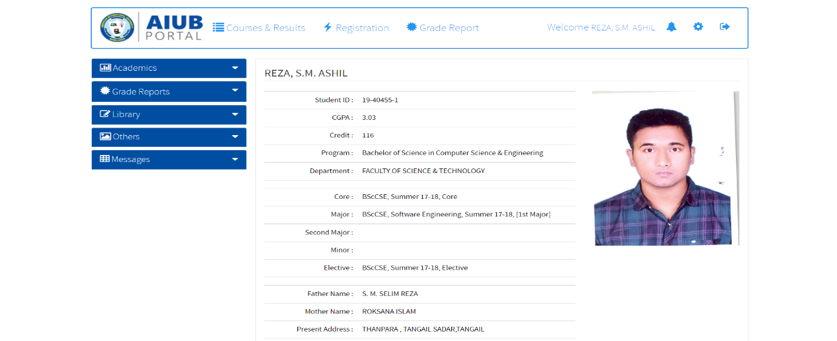

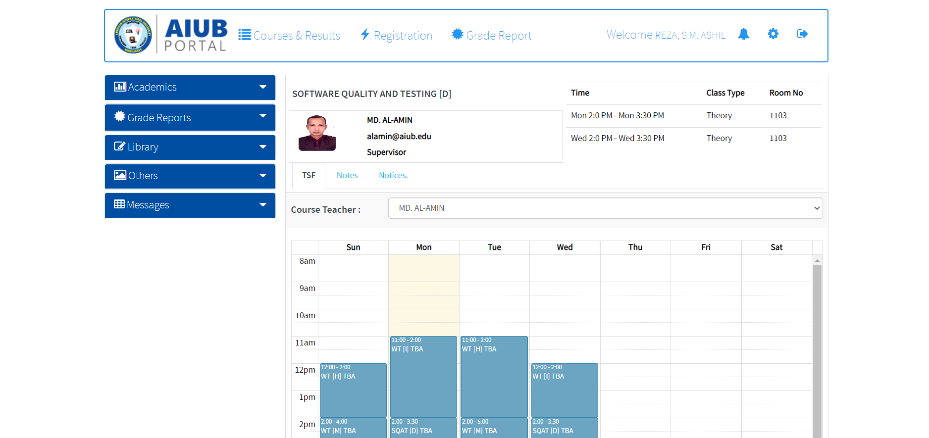

## Project Requirements

❖ Total Development Time 1 year 6 months

❖ Team member 5

❖ Office environment.

❖ Total budget 10,00,000 BD

❖ Total size of our project must be 500-900MB

# FEATURES NOT TO BE TESTED

The following is a list of the areas that will not be specifically addressed. All testing in these areas will be indirect as a result of other testing efforts. For example:

* How to perform our application under low network that will not be tested.
* External functionality over the program is not supported by this system. As a result, application to server testing should be avoided.

• Hardware

# TESTING APPROACH

## Testing Levels

* The testing for the AIUB portal system will consist of unit testing, integration/system testing, and acceptance testing. According to the budget and timeline established and planned, these testing will be done by the tester, QA team, and also the development teams.
* Unit testing will be done by the developers and will be approved by the development team lead. Proof of unit testing must be provided by the programmer to the team leader. This part includes, testing the interface design, and individual modules/parts of the whole system.
* Integration/system testing will be performed by the test manager and development team leader with the assistance of developers if required. After unit testing, this testing will focus on whether the integrated modules or the part of system or whole system is working properly or not.
* Acceptance testing involves the testers, QA team, and end-users who for testing the system to make sure it operates as expected and all their defined requirements. The testing will test whether the login is working or not, the interface is user-friendly or not etc.

## Test Tools

• For documentation, and error/bug reports, Microsoft word, and excel will be used.

• For another testing, the tester and QA team will do the tasks manually.

• Operating system will be windows 7.

## Meetings

A meeting is conducted with the technical staff to discuss the actual quality requirements of the software and the design quality of the prototype. The test team will meet once every week to evaluate the progress and identify all problems and conduct a solution. The test team will also meet with the development team to merge their ideas about testing and the quality of our website. Additional meetings can be called as required for emergency situations.

# TEST CASES/TEST ITEMS

|  |  |  |  |  |  |
| --- | --- | --- | --- | --- | --- |
| Project Name:  AIUB portal management system | | | Test Designed by:  Muhammad Ridowan Ahad | | |
| Test Case ID: TC_1 | | | Test Designed date: 17-08-2022 | | |
| Test Priority (Low, Medium, High): Low | | | Test Executed by:  Muhammad Ridowan Ahad | | |
| Module Name: Official AIUB webpage features | | | Test Execution date: 18-08-2022 | | |
| Test Title: verify all major features in the website | | |  | | |
| Description: Test AIUB webpage features | | |  | | |
| Precondition (If any):  User must visit official AIUB website | | | | | |
| Test Steps | Test Data | Expected Results | | Actual Results | Status (Pass/Fail) |
| 1. Go to <http://www.aiub.edu>  2. Find features: Home, About, Academics, Administration, Admission, Contact, Webmail, Login | Visited AIUB official website | Find features: Home, About, Academics, Administration, Admission, Contact, Webmail, Login | | As expected, | Pass |
| Post Condition: User will be redirected to official page of AIUB | | | | | |

|  |  |  |  |  |  |
| --- | --- | --- | --- | --- | --- |
| Project Name:  AIUB portal management system | | | Test Designed by: Muhammad Ridowan Ahad | | |
| Test Case ID: TC_2 | | | Test Designed date: 17-08-2022 | | |
| Test Priority (Low, Medium, High): Medium | | | Test Executed by:  Muhammad Ridowan Ahad | | |
| Module Name: Login | | | Test Execution date: 18-08-2022 | | |
| Test Title: Check login button | | |  | | |
| Description: Test AIUB portal home page | | |  | | |
| Precondition (If any):  User must be logged in the portal | | | | | |
| Test Steps | Test Data | Expected Results | | Actual Results | Status (Pass/Fail) |
| 1.Go to the Home page  3.Clicked on Login | There is no testable data for this test module | Clicking on ‘Login’ brings to a new login page | | As Expected, | Pass |
| Post Condition: User will be redirected to login page | | | | | |

|  |  |  |  |  |  |
| --- | --- | --- | --- | --- | --- |
| Project Name:  AIUB portal management system | | | Test Designed by: Muhammad Ridowan Ahad | | |
| Test Case ID: TC_3 | | | Test Designed date: 17-08-2022 | | |
| Test Priority (Low, Medium, High): High | | | Test Executed by: Muhammad Ridowan Ahad | | |
| Module Name: login page | | | Test Execution date: 18-08-2022 | | |
| Test Title: Check login page | | |  | | |
| Description: Test AIUB login page | | |  | | |
| Precondition (If any):  User must be on the login page | | | | | |
| Test Steps | Test Data | Expected Results | | Actual Results | Status (Pass/Fail) |
| 1.Go to the student portal  2.Go to the Home page  3.Clicked on Login  4. insert id and password in the Section of Id and password | Student id: 12-45678-9  Password: 33333333 | The login page containing a section of Student id and password for login and a login button. Also if any student cant to access their student portal or forget their password then there was a link to solve their problem named ‘Can’t access your account’ | | As Expected, | Pass |
| Post Condition: User should be on login page | | | | | |

|  |  |  |  |  |  |
| --- | --- | --- | --- | --- | --- |
| Project Name:  AIUB portal management system | | | Test Designed by: Muhammad Ridowan Ahad | | |
| Test Case ID: TC_4 | | | Test Designed date: 17-08-2022 | | |
| Test Priority (Low, Medium, High): High | | | Test Executed by: Muhammad Ridowan Ahad | | |
| Module Name: student portal | | | Test Execution date: 18-08-2022 | | |
| Test Title: student portal home page check | | |  | | |
| Description: Student portal | | |  | | |
| Precondition (If any):  User must be logged in the portal | | | | | |
| Test Steps | Test Data | Expected Results | | Actual Results | Status (Pass/Fail) |
| 1.Go to the student portal  2.Go to the Home page  3. login with student id and password | There is no testable data for this test module | After login with student Id and password the portal is opened and show the home page of the student portal | | As not expected | Failed |
| Post Condition: Home page of the student portal | | | | | |

|  |  |  |  |  |  |
| --- | --- | --- | --- | --- | --- |
| Project Name:  AIUB portal management system | | | Test Designed by: Muhammad Ridowan Ahad | | |
| Test Case ID: TC_5 | | | Test Designed date: 17-08-2022 | | |
| Test Priority (Low, Medium, High): High | | | Test Executed by: Muhammad Ridowan Ahad | | |
| Module Name: student portal home page | | | Test Execution date: 18-08-2022 | | |
| Test Title: student portal’s home page verification | | |  | | |
| Description: Student portal | | |  | | |
| Precondition (If any):  Check the student portal | | | | | |
| Test Steps | Test Data | Expected Results | | Actual Results | Status (Pass/Fail) |
| 1.Go to the student portal  2. verify if the student portal containing the course names and class scheduling, registered coursed, session, student profile, notification option, logout option, setting, registration, grade report, academics, library, others, massages | There is no testable data for this test module | The student portal containing the course names and class scheduling, registered coursed, session, student profile, notification option, logout option, setting, registration, grade report, academics, library, others, massages | | As Expected, | Pass |
| Post Condition: The account session details are destroyed from the database after logout | | | | | |

|  |  |  |  |  |  |
| --- | --- | --- | --- | --- | --- |
| Project Name: AIUB student portal system | | | Test Designed by:Abdullah-Al-Samad | | |
| Test Case ID: FR_6 | | | Test Designed date:18-38565-2 | | |
| Test Priority (Low, Medium, High): High | | | Test Executed by:Abdullah-Al-Samad | | |
| Module Name: academics | | | Test Execution date:18-08-22 | | |
| Test Title: checking academics option | | |  | | |
| Description: Test website’s academics | | |  | | |
| Precondition (If any): User must have valid username and password and also logged in the portal | | | | | |
| Test Steps | Test **Data** | Expected Results | | Actual Results | Status (Pass/Fail) |
| 1.Go to the student portal  2.Go to the Home page  3. login with student id and password | There is no testable data for this test module | When clicked on ‘Academics’, a drop-down list opens with the items –course & result, registration, drop application, offered course, my curriculum, financials. | | When clicked on ‘Academics’, a drop-down list opens with the items –course & result, registration, drop application, offered course, my curriculum, financials. | Pass |
| Post Condition: User is validated with database and successfully login to account. The account session details are logged in the database. | | | | | |

|  |  |  |  |  |  |
| --- | --- | --- | --- | --- | --- |
| Project Name: AIUB student portal system | | | Test Designed by:Abdullah-Al-Samad | | |
| Project Name: AIUB student portal system | | | Test Designed by:Abdullah-Al-Samad | | |
| Test Case ID: FR_7 | | | Test Designed date:18-38565-2 | | |
| Test Priority (Low, Medium, High): High | | | Test Executed by:Abdullah-Al-Samad | | |
| Module Name: course & result | | | Test Execution date:18-08-22 | | |
| Test Title: checking the course & result option | | |  | | |
| Description: Test website course & result | | |  | | |
| Precondition (If any): User must have valid username and password | | | | | |
| Test Steps | Test **Data** | Expected Results | | Actual Results | Status (Pass/Fail) |
| 1.Go to the student portal  2.Go to the Home page  3.Clicked on course & results | There is no testable data for this test module | When clicked on ‘course & results’ a list opens with all marks and number distribution, grades, all details of a course in mid term exam and final term exam.  . | | When clicked on ‘course & results’ a list opens with all marks and number distribution, grades, all details of a course in mid term exam and final term exam. | Pass |
| Post Condition: User is validated with database and successfully login to account. The account session details are logged in the database. | | | | | |

|  |  |  |  |  |  |
| --- | --- | --- | --- | --- | --- |
| Project Name: AIUB student portal system | | | Test Designed by:Abdullah-Al-Samad | | |
| Test Case ID: FR_8 | | | Test Designed date:18-38565-2 | | |
| Test Priority (Low, Medium, High): High | | | Test Executed by:Abdullah-Al-Samad | | |
| Module Name: registration | | | Test Execution date:18-08-22 | | |
| Test Title: checking registration option | | |  | | |
| Description: Test website registration | | |  | | |
| Precondition (If any): User must have valid username and password | | | | | |
| Test Steps | Test **Data** | Expected Results | | Actual Results | Status (Pass/Fail) |
| 1.Go to the student portal  2.Go to the Home page  3.Clicked on registration | There is no testable data for this test module | When clicked on ‘Registration’, a list opens with the details of course list of the semester and credit details, registration fees of the courses and others. | | When clicked on ‘Registration’, a list opens with the details of course list of the semester and credit details, registration fees of the courses and others. | Pass |
| Post Condition: User is validated with database and successfully login to account. The account session details are logged in the database. | | | | | |

|  |  |  |  |  |  |
| --- | --- | --- | --- | --- | --- |
| Project Name: AIUB student portal system | | | Test Designed by:Abdullah-Al-Samad | | |
| Test Case ID: FR_9 | | | Test Designed date:18-38565-2 | | |
| Test Priority (Low, Medium, High): High | | | Test Executed by:Abdullah-Al-Samad | | |
| Module Name: drop application | | | Test Execution date:18-08-22 | | |
| Test Title: checking drop application option | | |  | | |
| Description: Test website drop application | | |  | | |
| Precondition (If any): User must have valid username and password | | | | | |
| Test Steps | Test **Data** | Expected Results | | Actual Results | Status (Pass/Fail) |
| 1.Go to the student portal  2.Go to the Home page  3.Clicked on Drop application  . | There is no testable data for this test module | When clicked on ‘Drop application’, open a news pages for drop the courses also containing all-time course list and drop button with every course name. | | When clicked on ‘Drop application’, open a news pages for drop the courses also containing all-time course list and drop button with every course name. | Pass |
| Post Condition: User is validated with database and successfully login to account. The account session details are logged in the database. | | | | | |

|  |  |  |  |  |  |
| --- | --- | --- | --- | --- | --- |
| Project Name: AIUB student portal system | | | Test Designed by:Abdullah-Al-Samad | | |
| Test Case ID: FR_10 | | | Test Designed date:18-38565-2 | | |
| Test Priority (Low, Medium, High): High | | | Test Executed by:Abdullah-Al-Samad | | |
| Module Name: Grade report | | | Test Execution date:18-08-22 | | |
| Test Title: checking grade report | | |  | | |
| Description: Test website Grade report | | |  | | |
| Precondition (If any): User must have valid username and password | | | | | |
| Test Steps | Test **Data** | Expected Results | | Actual Results | Status (Pass/Fail) |
| 1.Go to the student portal  2.Go to the Home page  3.Clicked on grade report  . | There is no testable data for this test module | When clicked on ‘Grade report’, a drop-down list opens with the items – By curriculum, By semester. | | When clicked on ‘Grade report’, a drop-down list opens with the items – By curriculum, By semester. | Pass |
| Post Condition: User is validated with database and successfully login to account. The account session details are logged in the database. | | | | | |

|  |  |  |  |  |  |
| --- | --- | --- | --- | --- | --- |
| Project Name:  AIUB portal management system | | | Test Designed by: MD.Sadatur Rahman | | |
| Test Case ID: TC_11 | | | Test Designed date: 17-08-2022 | | |
| Test Priority (Low, Medium, High): Low | | | Test Executed by:MD.Sadatur Rahman | | |
| Module Name: By curriculum icon | | | Test Execution date: 18-08-2022 | | |
| Test Title: show all grades with semester course details | | |  | | |
| Description: Test AIUB portal home page | | |  | | |
| Precondition (If any):  User must be logged in the portal | | | | | |
| Test Steps | Test Data | Expected Results | | Actual Results | Status (Pass/Fail) |
| 1.Go to the student portal  2.Go to the Home page  3.Clicked on ‘By curriculum’ | There is no testable data for this test module | a drop-down list shows the information of grades with semester course details. | | Instead of a drop-down list, A new page is appeared where all the information of semester course details. | Fail |
| Post Condition: User must have close button of drop-down list | | | | | |

|  |  |  |  |  |  |
| --- | --- | --- | --- | --- | --- |
| Project Name:  AIUB portal management system | | | Test Designed by: MD.Sadatur Rahman | | |
| Test Case ID: TC_12 | | | Test Designed date: 17-08-2022 | | |
| Test Priority (Low, Medium, High): Medium | | | Test Executed by: MD.Sadatur Rahman | | |
| Module Name: By semester | | | Test Execution date: 18-08-2022 | | |
| Test Title: All grades with semester course details mid and final | | |  | | |
| Description: Test AIUB portal home page | | |  | | |
| Precondition (If any):  User must be logged in the portal | | | | | |
| Test Steps | Test Data | Expected Results | | Actual Results | Status (Pass/Fail) |
| 1.Go to the student portal  2.Go to the Home page  3.Clicked on By semester | There is no testable data for this test module | 1. a drop-down list shows the information of all grades with semester course details. | | As Expected, | Pass |
| Post Condition: User must have close button of drop-down list | | | | | |

|  |  |  |  |  |  |
| --- | --- | --- | --- | --- | --- |
| Project Name:  AIUB portal management system | | | Test Designed by: MD.Sadatur Rahman | | |
| Test Case ID: TC_13 | | | Test Designed date: 17-08-2022 | | |
| Test Priority (Low, Medium, High): Medium | | | Test Executed by: MD.Sadatur Rahman | | |
| Module Name: Library | | | Test Execution date: 18-08-2022 | | |
| Test Title: Check library page | | |  | | |
| Description: Test AIUB portal home page | | |  | | |
| Precondition (If any):  User must be logged in the portal | | | | | |
| Test Steps | Test Data | Expected Results | | Actual Results | Status (Pass/Fail) |
| 1.Go to the student portal  2.Go to the Home page  3.Clicked on settings icon | There is no testable data for this test module | 1. a drop-down list opens with the items –Search book, current borrows, borrow history, UGC digital library, SAGE, INASP, Research4life, Online Legal Research Database Bangladesh- BDLEX. | | As Expected, | Pass |
| Post Condition: User must have close button of drop-down list | | | | | |

|  |  |  |  |  |  |
| --- | --- | --- | --- | --- | --- |
| Project Name:  AIUB portal management system | | | Test Designed by: MD.Sadatur Rahman | | |
| Test Case ID: TC_14 | | | Test Designed date: 17-08-2022 | | |
| Test Priority (Low, Medium, High): High | | | Test Executed by: MD.Sadatur Rahman | | |
| Module Name: Others icon | | | Test Execution date: 18-08-2022 | | |
| Test Title: verify ‘other’ icon | | |  | | |
| Description: Test AIUB portal home page | | |  | | |
| Precondition (If any):  User must be logged in the portal | | | | | |
| Test Steps | Test Data | Expected Results | | Actual Results | Status (Pass/Fail) |
| 1.Go to the student portal  2.Go to the Home page  3.Clicked on others icon. | There is no testable data for this test module | 1. a drop-down list opens with the items –Application, parking Application, Download forms | | As Expected, | Pass |
| Post Condition: The account session details are destroyed from the database after logout | | | | | |

|  |  |  |  |  |  |
| --- | --- | --- | --- | --- | --- |
| Project Name:  AIUB portal management system | | | Test Designed by: MD.Sadatur Rahman | | |
| Test Case ID: TC_15 | | | Test Designed date: 17-08-2022 | | |
| Test Priority (Low, Medium, High): High | | | Test Executed by:MD.Sadatur Rahman | | |
| Module Name: Clicked on Message | | | Test Execution date: 18-08-2022 | | |
| Test Title: open the item -mail box | | |  | | |
| Description: Test AIUB portal home page | | |  | | |
| Precondition (If any):  User must be logged in the portal | | | | | |
| Test Steps | Test Data | Expected Results | | Actual Results | Status (Pass/Fail) |
| 1.Go to the student portal  2.Go to the Home page  3.Clicked on ‘message’ | There is no testable data for this test module | 1. a drop-down list opens with the items –mail box | | As Expected, | Pass |
| Post Condition: The account session details are destroyed from the database after logout | | | | | |

|  |  |  |  |  |  |
| --- | --- | --- | --- | --- | --- |
| Project Name:  AIUB portal management system | | | Test Designed by: REZA, S. M. ASHIL | | |
| Test Case ID: FR_16 | | | Test Designed date: 17-08-2022 | | |
| Test Priority (Low, Medium, High): medium | | | Test Executed by: REZA, S. M. ASHIL | | |
| Module Name: class scheduling | | | Test Execution date: 18-08-2022 | | |
| Test Title: checking the class scheduling courses details | | |  | | |
| Description: Test AIUB student portal home page | | |  | | |
| Precondition (If any):  User must be logged in the portal | | | | | |
| Test Steps | Test Data | Expected Results | | Actual Results | Status (Pass/Fail) |
| 1.Go to the student portal  2.Go to the Home page  3.Clicked on any course name | There is no testable data for this test module | when clicked on any course name, the system displays a page containing teacher’s photo, teacher’s name, teacher’s post, teacher’s department, teacher’s room number, teacher’s official mobile number (if the faculty want to share mobile number), course name, class time, class details, class room number, TSF, Notes, notices. | | when clicked on any course name, the system displays a page containing teacher’s photo, teacher’s name, teacher’s post, teacher’s department, teacher’s room number, teacher’s official mobile number (if the faculty want to share mobile number), course name, class time, class details, class room number, TSF, Notes, notices. | pass |
| Post Condition: User must have click any course name | | | | | |

|  |  |  |  |  |  |
| --- | --- | --- | --- | --- | --- |
| Project Name:  AIUB portal management system | | | Test Designed by: REZA, S. M. ASHIL | | |
| Test Case ID: FR_17 | | | Test Designed date: 17-08-2022 | | |
| Test Priority (Low, Medium, High): Low | | | Test Executed by: REZA, S. M. ASHIL | | |
| Module Name: TSF | | | Test Execution date: 18-08-2022 | | |
| Test Title: checking the TSF option | | |  | | |
| Description: Test AIUB student portal home page | | |  | | |
| Precondition (If any):  User must be logged in the portal | | | | | |
| Test Steps | Test Data | Expected Results | | Actual Results | Status (Pass/Fail) |
| 1.Go to the student portal  2.Go to the Home page  3.Clicked on any course name  4. click onk TSF | There is no testable data for this test module | When clicked on ‘TSF’, a list shows with the items – faculty’s courses (which courses the faculty take in the semester), course sections, class time, class rooms, consulting time. | | When clicked on ‘TSF’, a list shows with the items – faculty’s courses (which courses the faculty take in the semester), course sections, class time, consulting time. | failed |
| Post Condition: User must have click any course name | | | | | |

|  |  |  |  |  |  |
| --- | --- | --- | --- | --- | --- |
| Project Name:  AIUB portal management system | | | Test Designed by: REZA, S. M. ASHIL | | |
| Test Case ID: FR_18 | | | Test Designed date: 17-08-2022 | | |
| Test Priority (Low, Medium, High): high | | | Test Executed by: REZA, S. M. ASHIL | | |
| Module Name: Notes | | | Test Execution date: 18-08-2022 | | |
| Test Title: checking the notes option | | |  | | |
| Description: Test AIUB student portal home page | | |  | | |
| Precondition (If any):  User must be logged in the portal | | | | | |
| Test Steps | Test Data | Expected Results | | Actual Results | Status (Pass/Fail) |
| 1.Go to the student portal  2.Go to the Home page  3.Clicked on any course name  4. click on Notes | There is no testable data for this test module | When clicked on ‘Notes’, a drop-down list shows the notes which are uploaded by the faculty with file name, upload time & date, file size. | | When clicked on ‘Notes’, a drop-down list shows the notes which are uploaded by the faculty with file name, upload time & date, file size. | passed |
| Post Condition: User must have click any course name | | | | | |

|  |  |  |  |  |  |
| --- | --- | --- | --- | --- | --- |
| Project Name:  AIUB portal management system | | | Test Designed by: REZA, S. M. ASHIL | | |
| Test Case ID: FR_19 | | | Test Designed date: 17-08-2022 | | |
| Test Priority (Low, Medium, High): medium | | | Test Executed by: REZA, S. M. ASHIL | | |
| Module Name: notices | | | Test Execution date: 18-08-2022 | | |
| Test Title: checking the notices option | | |  | | |
| Description: Test AIUB student portal home page | | |  | | |
| Precondition (If any):  User must be logged in the portal | | | | | |
| Test Steps | Test Data | Expected Results | | Actual Results | Status (Pass/Fail) |
| 1.Go to the student portal  2.Go to the Home page  3.Clicked on any course name  4. click on notices | There is no testable data for this test module | When clicked on ‘Notices’, a drop-down list shows the notices which are given by the faculty. | | When clicked on ‘Notices’, a drop-down list shows the notices which are given by the faculty. | passed |
| Post Condition: User must have click any course name | | | | | |

|  |  |  |  |  |  |
| --- | --- | --- | --- | --- | --- |
| Project Name:  AIUB portal management system | | | Test Designed by: Sormila Hossain | | |
| Test Case ID: TC_20 | | | Test Designed date: 17-08-2022 | | |
| Test Priority (Low, Medium, High): Low | | | Test Executed by: Sormila Hossain | | |
| Module Name: welcome student name | | | Test Execution date: 18-08-2022 | | |
| Test Title: verify “welcome student name” text | | |  | | |
| Description: Test AIUB portal home page | | |  | | |
| Precondition (If any):  User must be logged in the portal | | | | | |
| Test Steps | Test Data | Expected Results | | Actual Results | Status (Pass/Fail) |
| 1.Go to the student portal  2.Go to the Home page  3.Clicked on ‘welcome student name’ | There is no testable data for this test module | a drop-down list shows the all the information of a student with student photo | | Instead of a drop-down list, A new page is appeared where all the information of a student with student photo is shows | Fail |
| Post Condition: User must have close button of drop-down list | | | | | |

|  |  |  |  |  |  |
| --- | --- | --- | --- | --- | --- |
| Project Name:  AIUB portal management system | | | Test Designed by: Sormila Hossain | | |
| Test Case ID: TC_21 | | | Test Designed date: 17-08-2022 | | |
| Test Priority (Low, Medium, High): Medium | | | Test Executed by: Sormila Hossain | | |
| Module Name: Notification icon | | | Test Execution date: 18-08-2022 | | |
| Test Title: Check notification icon | | |  | | |
| Description: Test AIUB portal home page | | |  | | |
| Precondition (If any):  User must be logged in the portal | | | | | |
| Test Steps | Test Data | Expected Results | | Actual Results | Status (Pass/Fail) |
| 1.Go to the student portal  2.Go to the Home page  3.Clicked on notification icon | There is no testable data for this test module | a drop-down list shows all the updates from our faculty | | As Expected, | Pass |
| Post Condition: User must have close button of drop-down list | | | | | |

|  |  |  |  |  |  |
| --- | --- | --- | --- | --- | --- |
| Project Name:  AIUB portal management system | | | Test Designed by: Sormila Hossain | | |
| Test Case ID: TC_22 | | | Test Designed date: 17-08-2022 | | |
| Test Priority (Low, Medium, High): Medium | | | Test Executed by: Sormila Hossain | | |
| Module Name: Settings icon | | | Test Execution date: 18-08-2022 | | |
| Test Title: Check settings icon | | |  | | |
| Description: Test AIUB portal home page | | |  | | |
| Precondition (If any):  User must be logged in the portal | | | | | |
| Test Steps | Test Data | Expected Results | | Actual Results | Status (Pass/Fail) |
| 1.Go to the student portal  2.Go to the Home page  3.Clicked on settings icon | There is no testable data for this test module | a drop-down list shows change password option | | As Expected, | Pass |
| Post Condition: User must have close button of drop-down list | | | | | |

|  |  |  |  |  |  |
| --- | --- | --- | --- | --- | --- |
| Project Name:  AIUB portal management system | | | Test Designed by: Sormila Hossain | | |
| Test Case ID: TC_23 | | | Test Designed date: 17-08-2022 | | |
| Test Priority (Low, Medium, High): High | | | Test Executed by: Sormila Hossain | | |
| Module Name: Logout Session | | | Test Execution date: 18-08-2022 | | |
| Test Title: verify logout icon | | |  | | |
| Description: Test AIUB portal home page | | |  | | |
| Precondition (If any):  User must be logged in the portal | | | | | |
| Test Steps | Test Data | Expected Results | | Actual Results | Status (Pass/Fail) |
| 1.Go to the student portal  2.Go to the Home page  3.Clicked on logout icon | There is no testable data for this test module | User should go to the login page | | As Expected, | Pass |
| Post Condition: The account session details are destroyed from the database after logout | | | | | |

# ITEM PASS/FAIL CRITERIA

* Unit test is done in each and every module or feature
* All the modules added one by one and integration test done after every module integrated
* 100% integration test passed
* No major defects are outstanding
* Not more than 15 minor defects are outstanding
* Code coverage tools indicates all code covered
* Ensuring all critical Test Cases are passed
* identifying and fixing all the high-priority defects

# TEST DELIVERABLES

The Software Quality and Testing Plan defines the technical and managerial processes necessary for the system's development and delivery

❖ Acceptance test plan.

❖ System/Integration test plan

❖ Unit test plans documentation

❖ Screen prototypes

❖ Report mock-ups

❖ Defect/Incident reports and summaries

❖ Test Cases

❖ Test Plan Document

❖ Test Strategy

❖ Test Summary Report

❖ Test Status Report

❖ Test Evaluation Report

❖ Error Corrective Actions

❖ Execution Log Files

❖ Summary

# STAFFING AND TRAINING NEEDS

To manage the AIUB portal:

* More than 10 days of training need to the faculties for handle courses and the students.
* Maintenance staffing need to maintain the portal and its need
* Testing staffing need to test the bugs of the portal
* More than 3 months of Training need to the tester on selenium ide and Postman API

# RESPONSIBILITIES

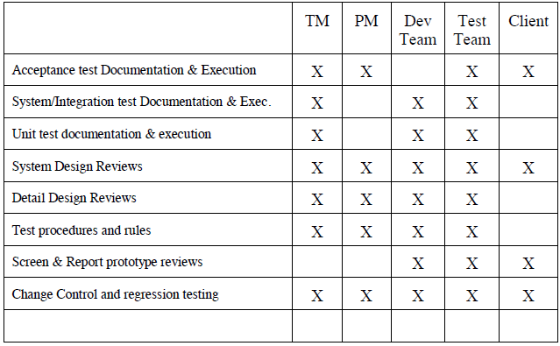

# TESTING SCHEDULE

The project schedule includes time for the upcoming testing activities. The project plan timetable specifies the precise hours and dates for each task. the necessary individuals.

The project timeline and plan also provide thorough descriptions of each process. The project manager, working with the development and test team leaders, will coordinate the employees needed for each task, the test team, the development team, management, and the customer.

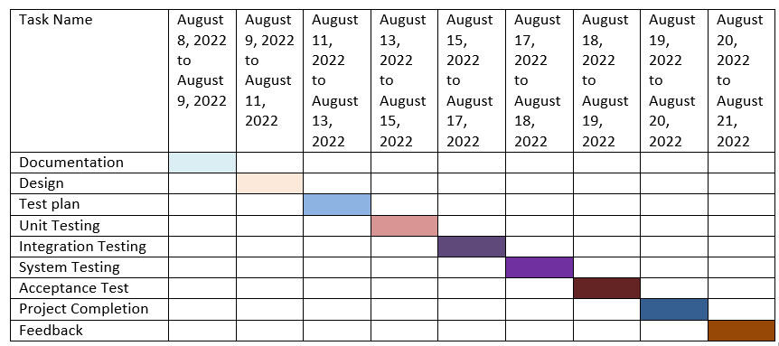

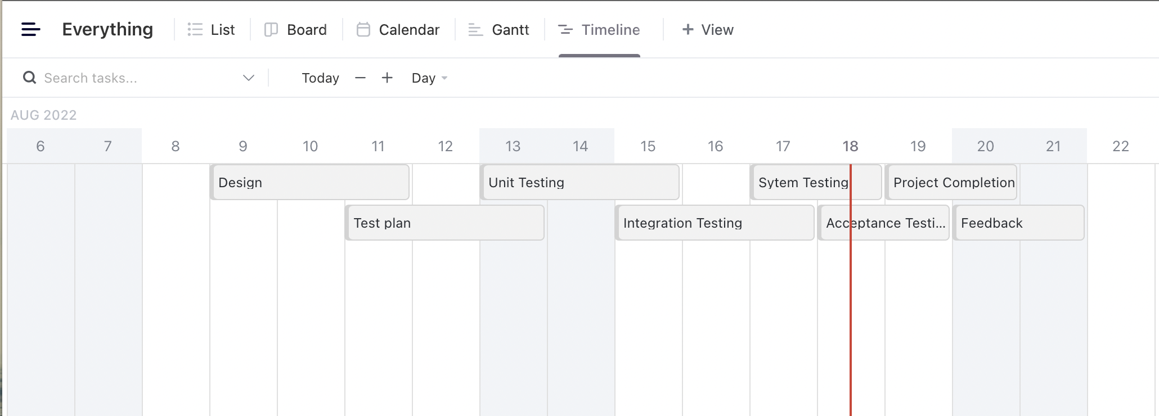

# PLANNING RISKS AND CONTINGENCIES

There are some risks and contingencies in every project. Sometimes deadline cannot bemeet due to change in requirements. Some employee might leave the project. This mayalso delay theproject. Due to insufficient fund project may also get delayed.

# APROVALS

|  |  |  |  |  |
| --- | --- | --- | --- | --- |
| **Name** | **Designation** | **Institute** | **Signature** | **Date** |
| Sormila Hossain | Test lead | AbcSoft Inc | Sormila | 18-08-2022 |
| Abdullah Al Samad | Moderator | AbcSoft Inc | Abdullah | 17-08-2022 |
| Md. Sadatur Rahman | QA Tester | AbcSoft Inc | Sadatur | 17-08-2022 |
| Muhammad Ridowan Ahad | QA tester | AbcSoft Inc | Ahad | 17-08-2022 |
| S.M. Ashil Reza | Project manager | AbcSoft Inc | Ashil | 19-08-2022 |